BOOKING PORTAL SERVICES
@CREATIVITY THINK (9483175986/7019689991)

ABSTRACT:
Booking Portal Services is a web application designed to streamline the booking and management of various service providers such as salons, repair services, and rental equipment. Users can browse services, book time slots, confirm bookings through a dashboard, rate providers, and view history. Administrators manage services, review bookings, analyze dashboard data, and oversee ratings. Built using Django and Django Rest Framework for backend operations and React with Redux and Recharts for frontend dashboards, the system ensures real-time booking management, review tracking, and analytics. This platform enhances customer experience and operational efficiency for service-based businesses..

INTRODUCTION OF THE PROJECT:
Managing bookings for multiple services can be challenging due to inconsistent schedules, manual tracking, and lack of analytics. Booking Portal Services offers a centralized web platform where users can book service providers, confirm appointments, leave ratings, and track their booking history. Administrators have tools to manage service listings, review bookings, monitor ratings, and analyze performance data through dashboards. Using Django for backend services and React with Redux and Recharts for interactive dashboards, the system provides a reliable, real-time, and user-friendly solution for service management, ensuring efficiency for both users and administrators..

PROJECT OBJECTIVES:

• Provide a web platform for booking services efficiently
• Enable users to browse, book, and confirm service appointments
• Allow users to rate and review service providers
• Offer administrators tools to manage service listings and bookings
• Generate analytics dashboards for service performance
• Track ratings and feedback for quality assurance
• Improve operational efficiency and customer satisfaction

PROBLEM OF THE STATEMENT:
Customers often face difficulties in finding service availability, booking appointments, and tracking their service history manually. Service providers struggle with managing schedules, tracking bookings, and collecting feedback efficiently. Administrators lack real-time data and analytics to optimize operations. Booking Portal Services addresses these challenges by offering a centralized system for browsing services, booking slots, managing ratings, and analyzing operational data. This ensures timely bookings, improved service quality, real-time updates, and actionable insights for administrators..

MOTIVATION OF THE PROJECT:
• Simplify booking processes for multiple service providers
• Provide users with a dashboard to track and review bookings
• Enable administrators to manage services and analyze performance
• Enhance customer satisfaction through ratings and feedback
• Reduce manual scheduling errors and improve operational efficiency

BLOCK DAIGRAM OF PROJECT:

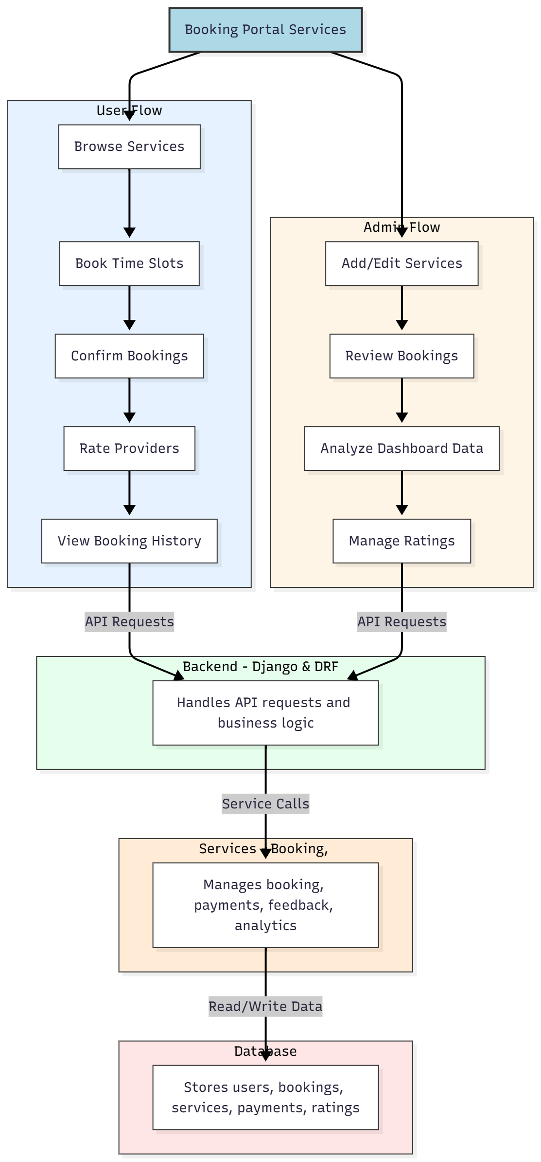

WORKING OF THE PROJECT:
Users log in to browse available services, select time slots, confirm bookings, rate providers, and track their booking history. The backend handles authentication, booking logic, and API requests. The services layer processes booking confirmations, payments, feedback, and analytics dashboards. Administrators add, edit, or delete service listings, review bookings, manage ratings, and analyze performance data through dashboards. This integrated system provides a seamless experience for users while giving administrators comprehensive tools to manage service operations efficiently..

SOFTWARE REQUIREMENT:
- Backend:
  - Python 3.x
  - Django
  - Django REST Framework
  - SQLite/PostgreSQL
- Frontend:
  - Node.js and npm
  - React.js
  - Axios
- Development Tools:
  - Visual Studio Code
  - Postman (for testing APIs)
  - Git/GitHub (for version control)
- Server/Deployment (Optional):
  - Gunicorn, Nginx, or Heroku/AWS for hosting

ADVANTAGES OF THE PROJECT:

• Streamlined service booking and management
• Dashboard for tracking bookings and ratings
• Real-time updates for users and administrators
• Payment and feedback integration
• Centralized management of services and providers
• Analytics dashboards for performance insights
• Reduces manual scheduling errors
• Enhances user satisfaction and service quality

APPLICATIONS OF THE PROJECT:
• Salons and spa booking systems
• Repair and maintenance service management
• Equipment rental bookings
• Freelance service management
• Customer feedback and rating systems
• Online appointment portals
• Service provider operational analytics
• Centralized booking dashboards for administrators

REFERENCES:

- Django REST Framework Documentation — Django Software Foundation. Django Documentation. Available: https://docs.djangoproject.com/
- Django REST Framework. DRF Documentation. Available: https://www.django-rest-framework.org/
- React. React Official Documentation. Available: https://reactjs.org/docs/getting-started.html
- Redux. Redux Documentation. Available: https://redux.js.org/introduction/getting-started
- PostgreSQL Global Development Group. PostgreSQL Documentation. Available: https://www.postgresql.org/docs/
- MySQL. MySQL Reference Manual. Available: https://dev.mysql.com/doc/
- Git. Git Documentation. Available: https://git-scm.com/doc
- Node.js. Node.js Documentation. Available: https://nodejs.org/en/docs/
- Axios. Axios Documentation. Available: https://axios-http.com/docs/intro
- Socket.io Documentation – https://socket.io/docs/

